Current State System Architecture 2015

The current state application architecture is a highly complex integration of existing and new solutions having different platforms, hardware and software, multiple data sources with some manual, and little automated process. It provides a context for system development or enhancement. Applications areas within systems represent a useful subdivision of activities, services, and data that can be linked to other objects in the architecture. They are a group of activities and entity types with strong interdependencies such that a single application or more than one application can support the area. In the past applications communicated often via manual processes to manager large transfer of data. Files were transferred manually using ad-hoc transfer solutions, such as FTP.

Figure 4-2 shows how outputs from some systems feed into other systems via arrows.

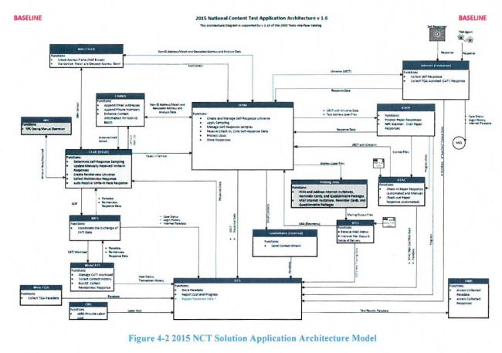

Target State System Architecture 2020

Based on a SOA paradigm where each application will provide services to the overall solution. In providing these services, these applications, can dictate development of technical enhancements and defining design patterns, APIs, Web Services, use of ESB, mobile, and cloud technologies. The ability to allow applications to use integrates enterprise data models to communicate with other systems and share data.

This modernization will consider the interoperability and interfacing elements such as data format, type, size, frequency, and performance elements such as throughput, response time, and quality of service. Future state will utilize Enterprise Integration Patterns based on API, ESB, and Managed File Transfer (MT) software to securely and efficiently share data across systems.

The target state application architecture will be a set of application areas identified to support the 2020 census. It provides a context for system development or enhancement. Application areas represent a useful subdivision of activities, services, and data that can be linked to other objects in the architecture. There will be a group of activities and entity types with strong interdependencies such that a single application or more than one application can support the area.

Target state will consist of both legacy application enhancements and new application development efforts. Projects such as CEDCap will replace multiple legacy systems used during the 2010 Census, while other legacy applications such as CIRA will remain to support the 2020 Census.   
  
Figure 5-4 shows how multiple systems will interact with both the legacy and new systems.

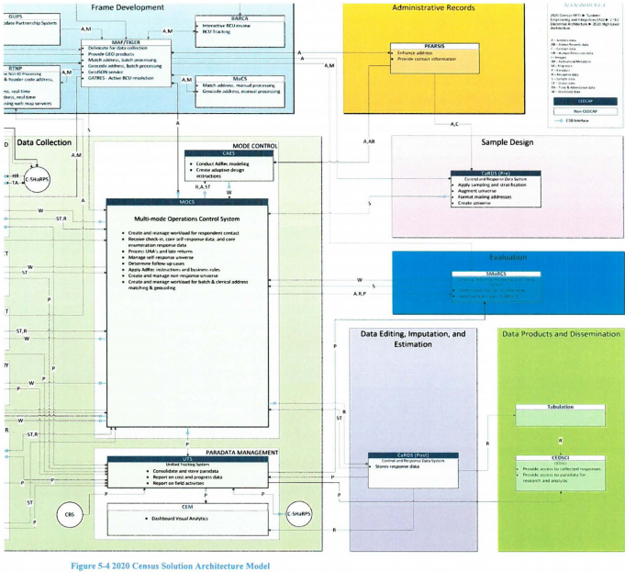

The Census System architecture view from 2015 to 2020 has several tests from current to target state.

2015 National Content Test (NCT)

The 2015 NCT evaluated and compared different census questionnaire content. The main focus was to test out multiple content forms with multiple mails out strategies.

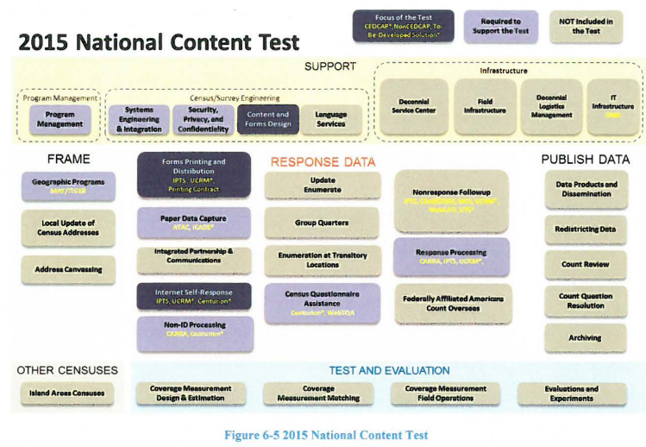

The 2016 National Census Test

Is designed to build on the 2015 NCT and introduce new systems and capabilities into the operational suite. The 2016 test focuses on the integration of self-response and Nonresponse followup operations. The introducing of CEDCap is meant to help with the self-response portion.

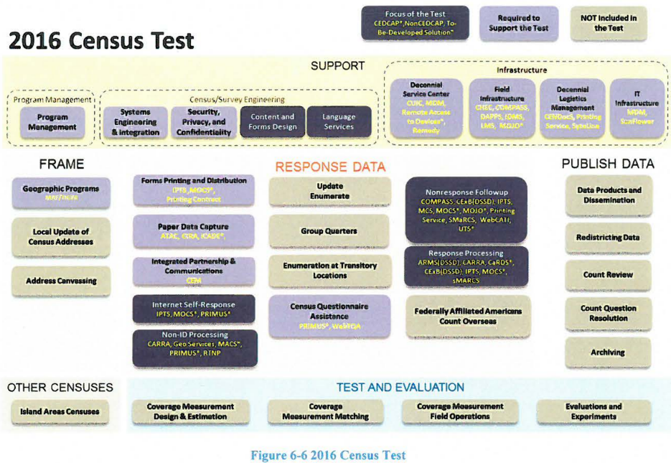

The 2017 Census Test and Address Canvassing (AdCan) Test

In 2017 the Census Bureau starts using the address canvassing (AdCan) test. The AdCan test is designed specifically to exercise new features to allow the Census Bureau to add new addresses to the existing address framework by using geographic information systems, aerial imagery and other data sources instead of sending Census Bureau employees to walk and physically check 11 million census blocks.

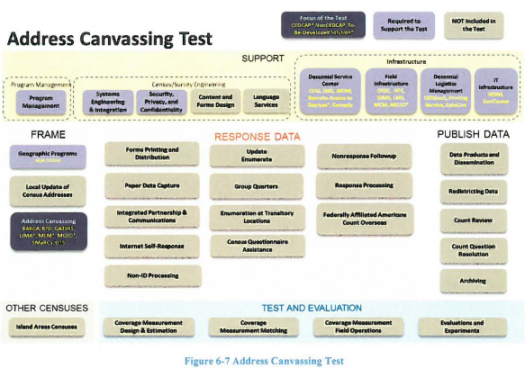

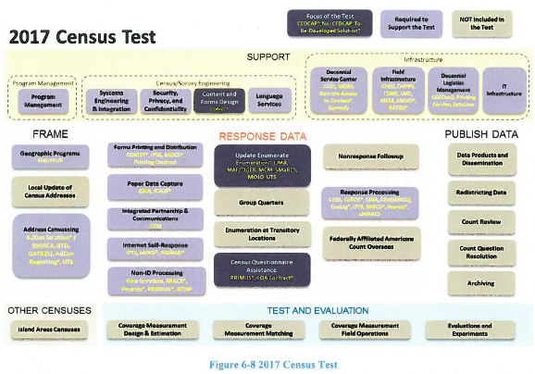

The 2018 End-to-End Census Test

The 2018 test is designed to be a large scale test for the 2020 Census. The intent is to fully exercise all major operations and systems in preparation for the Decennials counts. The goal is to have operational designs ready for production especially from a systems perspective.

The 2018 test is intended to mirror what will happen for 2020. The actual amount of data collected will not be as much as the 2020 census but false data will be used for stress testing. One of the main goals of the 2018 test is to automate some of the systems that were heavily manual in 2010 using the Coverage Measurement System. The Coverage Measurement system will take advantage of the centralized person-matching system that will be created for the 2020 Census efforts.

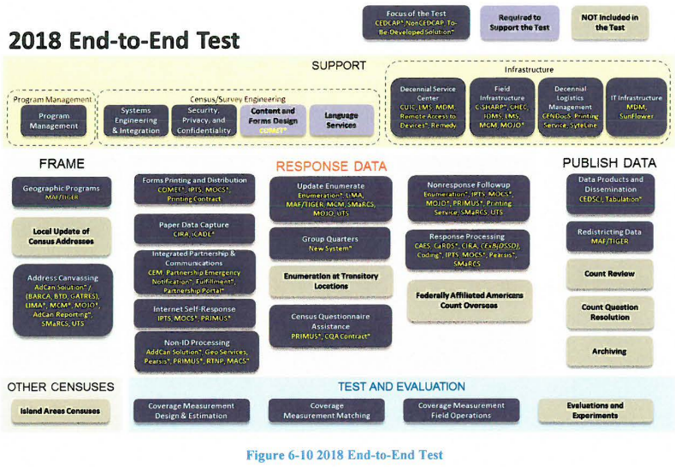

The 2019 Testing

There will be two types of testing for 2019. Defect resolution testing and Post End-to-End performance testing. The defect resolution testing will make sure that any changes made to fix defects from the 2018 test are resolved for the 2020 test. The Post end to end test will ensure that the solution as a whole is satisfied scalability, availability, and reliability.

The 2020 Decennial Census

The 2020 Census will be the actual census conducted to meet the constitutional requirement of determining the United States population every 10 years. The 2020 census will take lessons learned from the past 5 years and hopefully incorporate those into a successful census. That will make best use of resources used, time spent, and overall quality of data.

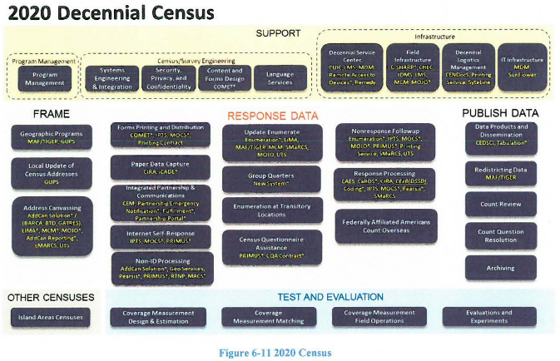

Main systems to be used:

Unified tracking system-Is an existing application used by Field ROs and Headquarters survey managers. The UTS will require changes to the existing interfaces, the ability to generate new reports, change old reports, in order to support the address canvassing operating.

Operational control system-will be used to manage the in-field address canvassing with the ability to create list crews of workers, make assignments, and generate reports both daily and in near real time.

Lima-part of CEDCAP program-Intially built for laptop but will be introduced on a handeld for mobility. Lima captures the GQ data for AdCan test that has not previously been captured.

National Finance Center- will perform payroll/personnel functions for field staff.

MCM-part of CEDCAP program-will be used for mobile case management.

SMaRCS-Based on the MaRCS 2010 system, performs re-interview QC sample selection and re-interview case matching to detect false data.

CARRA-Will be used to support administrative records for modeling and optimizing NRFU workload operations.

CEM-Will be used for data analytics, reporting customer exeriences, and importing response data from the old CaRDs system.

MaCs-Will be introduced to support manual matching and address geocoding of Non-ID cases.